Mission
- Goat Specialist
- Admin

- 5,082 posts
- Gender:Male
- Location:Monroe, MI
- Interests:Scholarly piracy, designing and creating haunted house rooms and props, movies, abstract thinking, abstruse thinking, obstructive thinking, ideating, random thinking, movies, cartoons, movies, movies scores, cycling, world peace and small furry dogs, movies, writing, drawing, personal skills training, gremlins and, of course, lest I forget, movies.
Posted January 26, 2012 · Report post
Of a ship's cook and a ship's carpenter. Anyone seen anything like that?

Fox
- Old Twillian
- Moderator

- 2,564 posts
- Gender:Male
- Location:Beautiful lush Devon, England
- Interests:Nautical history of the 16-18th centuries and living history based thereon.
Shooting pirates.
Posted January 26, 2012 · Report post
Can easily do you images from the second half of the 18th century if that's any good?
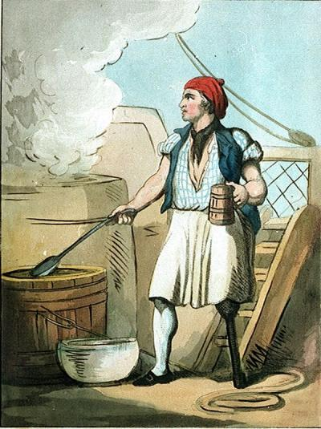
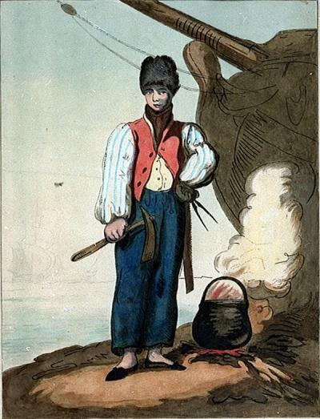
GAoP images may take a little longer...

Mission
- Goat Specialist
- Admin

- 5,082 posts
- Gender:Male
- Location:Monroe, MI
- Interests:Scholarly piracy, designing and creating haunted house rooms and props, movies, abstract thinking, abstruse thinking, obstructive thinking, ideating, random thinking, movies, cartoons, movies, movies scores, cycling, world peace and small furry dogs, movies, writing, drawing, personal skills training, gremlins and, of course, lest I forget, movies.
Posted January 26, 2012 · Report post
That first one may do for the cook. Where are those from?

Fox
- Old Twillian
- Moderator

- 2,564 posts
- Gender:Male
- Location:Beautiful lush Devon, England
- Interests:Nautical history of the 16-18th centuries and living history based thereon.
Shooting pirates.
Posted January 26, 2012 · Report post
They're by Thomas Rowlandson, published 1799.

Mission
- Goat Specialist
- Admin

- 5,082 posts
- Gender:Male
- Location:Monroe, MI
- Interests:Scholarly piracy, designing and creating haunted house rooms and props, movies, abstract thinking, abstruse thinking, obstructive thinking, ideating, random thinking, movies, cartoons, movies, movies scores, cycling, world peace and small furry dogs, movies, writing, drawing, personal skills training, gremlins and, of course, lest I forget, movies.
Posted January 26, 2012 · Report post
I notice the cook has a peg-leg. Very nice. I make a point in the thing I'm putting together about how the cooks were chosen more for their inablilty to serve as regular seaman than their ability to actually cook. (Although it is just a side point.)

peglegstrick
- Dread Pyrate
- Member

- 1,203 posts
- Gender:Male
- Location:Funston Ga
Posted January 26, 2012 · Report post
On 1/26/2012 at 6:53 PM, Mission said:
I notice the cook has a peg-leg. Very nice. I make a point in the thing I'm putting together about how the cooks were chosen more for their inablilty to serve as regular seaman than their ability to actually cook. (Although it is just a side point.)
I resemble that remark!

PoD
- Pyrate Captain
- Member

- 696 posts
- Gender:Male
- Location:Warrington UK
- Interests:Pirates, graphic novels, computer art, Listening to music, Going to gigs, Beer and Wine drinking, historical research, Period weaponry and Leatherwork
Posted January 26, 2012 · Report post
maybe he was just really dedicated to his job and he'd ran out of meat that day

Mission
- Goat Specialist
- Admin

- 5,082 posts
- Gender:Male
- Location:Monroe, MI
- Interests:Scholarly piracy, designing and creating haunted house rooms and props, movies, abstract thinking, abstruse thinking, obstructive thinking, ideating, random thinking, movies, cartoons, movies, movies scores, cycling, world peace and small furry dogs, movies, writing, drawing, personal skills training, gremlins and, of course, lest I forget, movies.
Posted January 27, 2012 · Report post
Somewhere I read that a man who was wounded in such a way that he could no longer serve as a sailor (say, an amputated leg or something) was made the cook rather than be discharged. As I understand it, being let go could be a pretty difficult problem at this time in history given the apprentice system. Many people held the same job for their entire lives after their multi-year apprenticeship. So it was sort of a mercy thing - again, if I remember and understand it correctly.
I thought I had it in my notes, but I can't find it now.

Silver
- Plunderer
- Member

- 347 posts
- Gender:Male
- Location:Virginia Beach, Virginia
- Interests:Maritime history
Posted January 27, 2012 · Report post
like the long john silver character. i bougth the one with charlton heston it pretty good.

Swashbuckler 1700
- Dread Pyrate
- Member

- 1,115 posts
- Gender:Male
- Location:Europe
- Interests:pyrates, pryvateers, naval military and other history, different books, good movies, music (a little bit), drawing, games,...
Posted February 9, 2012 · Report post
Well there is some pictures about Peter the great representing him as carpenter working in Dutch- and English shipyard. That are this paintings and engravings entirely truthfull is case of debate but there is some 18th century pics.
here

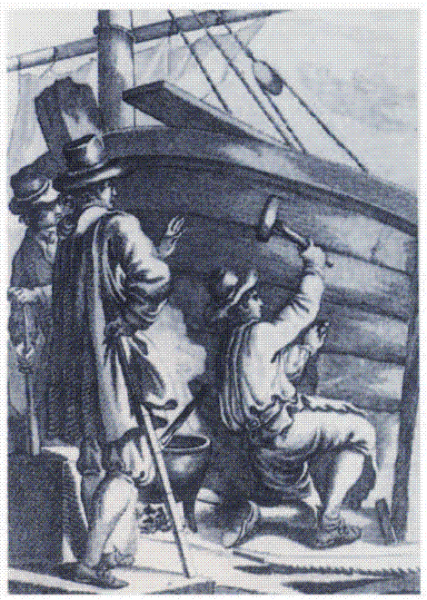

Mission
- Goat Specialist
- Admin

- 5,082 posts
- Gender:Male
- Location:Monroe, MI
- Interests:Scholarly piracy, designing and creating haunted house rooms and props, movies, abstract thinking, abstruse thinking, obstructive thinking, ideating, random thinking, movies, cartoons, movies, movies scores, cycling, world peace and small furry dogs, movies, writing, drawing, personal skills training, gremlins and, of course, lest I forget, movies.
Posted February 9, 2012 · Report post
Nice photo of a carpenter working on a ship there! (Be he Peter the Great or not.) Thanks! Do you happen to know the source of that?

Swashbuckler 1700
- Dread Pyrate
- Member

- 1,115 posts
- Gender:Male
- Location:Europe
- Interests:pyrates, pryvateers, naval military and other history, different books, good movies, music (a little bit), drawing, games,...
Posted February 9, 2012 (edited) · Report post
On 2/9/2012 at 2:47 PM, Mission said:
Nice photo of a carpenter working on a ship there! (Be he Peter the Great or not.) Thanks! Do you happen to know the source of that?
The portrait has been many books and various wedsites....I would dare to say it is from circa early 18th century....
There is source of other picture http://www.dbnl.org/...601_01_0048.php
Edited February 9, 2012 by Swashbuckler 1700

Mission
- Goat Specialist
- Admin

- 5,082 posts
- Gender:Male
- Location:Monroe, MI
- Interests:Scholarly piracy, designing and creating haunted house rooms and props, movies, abstract thinking, abstruse thinking, obstructive thinking, ideating, random thinking, movies, cartoons, movies, movies scores, cycling, world peace and small furry dogs, movies, writing, drawing, personal skills training, gremlins and, of course, lest I forget, movies.
Posted February 9, 2012 · Report post
Aha! The artist is Reinier Vinkeles, who lived 1741-1816.
While using Google Image search, I also found this engraving by the ever-popular artist 'Anonymous' which was done in 1701, which I think should be posted somewhere and here is as good a place as any. (Someone should let Ratbeard aka. Redbeard know that we have period evidence that putting small animals in one's mouth is accurate.)
